5.110: The passenger’s velocity is 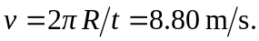 The vertical component of the seat’s force must balance the passenger’s weight and the horizontal component must provide the centripetal force. Therefore:
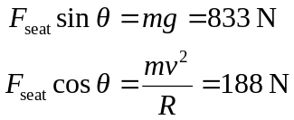
Therefore above the horizontal. The magnitude of the net force exerted by the seat (note that this is not the net force on the passenger) is
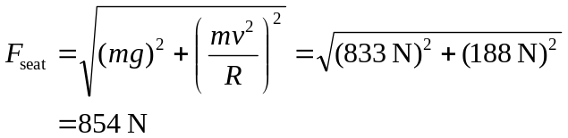
(b) The magnitude of the force is the same, but the horizontal component is reversed.

